Sheet (4)

- In a nonmagnetic medium (μ_{o} and ε) if the electric field intensity of a plane wave is given by:
Determine and calculate the following:
a) ε_{r} and λ.
b) The time-average power density of the wave, Pdav .
c) The total time-average power, Ptav crossing a normal area, A = 100 cm²

- Consider a plane wave normally incident on a half-space of copper (σ = 5.813x10⁷ S/m, µ_{r} = 1 and ε_{r} = 1). If wave frequency, f = 1 GHz, compute:
- The propagation constant or wave number, γ..
- The intrinsic impedance, η.
- The skin depth, δ_{s} for the conductor.
- The reflection coefficient, Γ.
- The transmission coefficient, T.

- Consider a plane wave normally incident from free space on a half-space of a medium 1 with parameters (µ_{r} = 1 and ε_{r} =2.5) as shown in Fig. 1. If the wave frequency, f = 1 GHz and the incident electric field in the phasor form, for z < 0 is:
where E⁺ = 10 mV/m, find the phasor and instantaneous values of the incident wave (Ei ,Hi ), the reflected wave ( Er , Hr ) and the transmitted wave ( Et , Ht ).
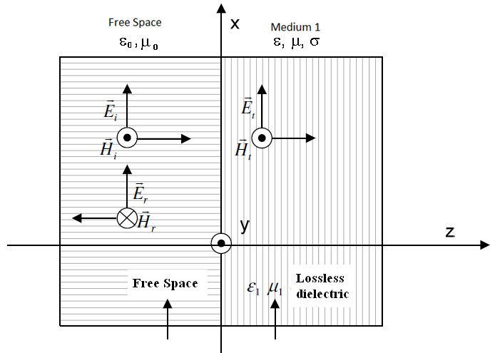

- Consider a plane wave normally incident from the free space on a half-space of a medium with parameters (σ = 0, µ = µ_{o}, ε = 3.3 ε_{o}). If the wave frequency f = 1.5 GHz and the incident electric field intensity in the phasor form, for z < 0 is:
Determine and calculate the phasor and instantaneous form value of the following:
a) The incident magnetic field intensity H, and the incident average power density, Pidav
b) The reflected wave (Er , Hr ) and the reflected average power density, .
c) The transmitted wave ( Et , Ht ) and the transmitted average power density, .

